**Sterilizations of Transvaginal Probes**

**G10VPL GUS Disinfection Soak Station**

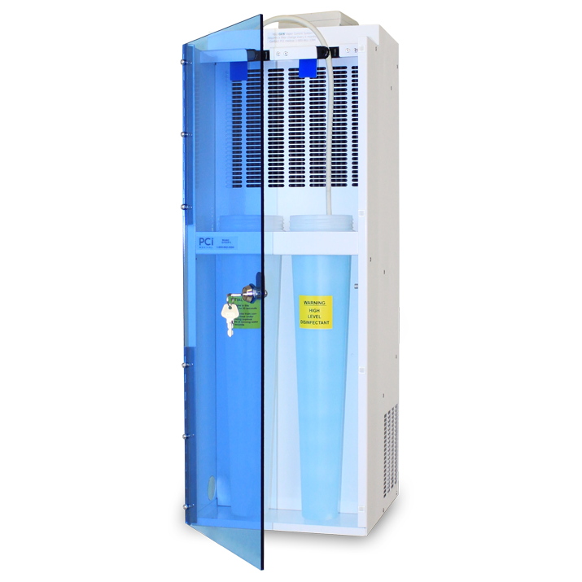

GUS Disinfection Soak Stations™ help protect your staff and patients from disinfectant fumes, while helping you to meet Joint Commission and OSHA standards. GUS stations are compatible with disinfectants (OPA, glutaraldehyde, hydrogen peroxide).

* Enclosed for increased protection from fumes
* Safety door allows for placement in patient area
* Long containers disinfect above the probe handle to help prevent *cross-contamination* of the cable
* Only uses 1.3 quarts (1/3 gallon) of disinfectant
* Compatible with OPA, glutaraldehyde & hydrogen peroxide

**Cleaning Gus Unit**

* Remove the rinse water container, empty and wash both the container and cap.
* Using mild detergent solution on a soft cloth, wipe down the area around the containers.
* Wipe off any drips around the disinfectant container and cap and below the shelf.
* Do not spray cleaning liquids on the intake area of the machine as this will damage the filter.
* After during the areas, replace the rinse water and disinfectant containers.

**Filling the Containers**

.

* Plug in the unit and switch it on using the ON/OFF switch located on left side of unit. The red indicator will light when the unit is operating.
* The G10VP has two containers: one for disinfectant and one for rinse water.
* Some disinfectants require activation before use. Pour the disinfectant into the soaking container. DO NOT fill above the lower shoulder of the container.
* To prevent evaporation of disinfectant, always replace the screw caps on the containers after removing the probes.
* Fill the remaining container with clean rinse water for the preliminary rinse. You MUST have one container for rinse water. This ensures that when the probe is removed from the unit for the final rinse, no high level disinfectant will drip or off-gas.

**Cleaning Probes**

* Remove any sheath or condom, wipe off gel, and wash probe with enzymatic cleaner prior to disinfection. Follow enzymatic manufacturer’s instructions.
* Place probe in Cidex solution in Gus unit for 12 – 15 minutes.
* Remove probe and rinse in water in Gus unit for 30 seconds.
* Rinse under running water for at least 30 seconds. Then dry probe and replace on ultrasound machine

**Solution Disposal**

* Solution should be poured into another container for disposal and add one

bottle of Glute-Out power into container with the Cidex OPA, and let solution sit for 5 minutes.

* Cidex OPA with the added Glute Out that has been sitting for 5 minutes can now be poured down the sink. Rinse sinks well after disposal.

**GUS Unit Disinfection Soak Station Knowledge Check**

1. GUS Disinfection Soak Stations™ help protect your staff and patients from disinfectant fumes, while helping you to meet Joint Commission and OSHA standards. GUS stations are compatible with disinfectants:

* OPA,
* glutaraldehyde,
* hydrogen peroxide
* All of the above

2. The amount of Solution needed in the Gus Unit

* It uses 1.3 quarts (1/2gallon) of disinfectant
* It uses 1.3 quarts (1/3 gallon) of disinfectant
* It uses 1.3 quarts (1/4 gallon) of disinfectant
* Remove the rinse water container, empty and wash both the container and cap.
* Using mild detergent solution on a soft cloth, wipe down the area around the containers.
* Wipe off any drips around the disinfectant container and cap and below the shelf.
* Do not spray cleaning liquids on the intake area of the machine as this will damage the filter.
* After during the areas, replace the rinse water and disinfectant containers.
* All of the above

**3. Cleaning Gus Unit** (Check all that apply)

* Plug in the unit and switch it on using the ON/OFF switch located on left side of unit. The red indicator will light when the unit is operating.
* The G10VP has two containers: one for disinfectant and one for rinse water.
* Pour the disinfectant into the soaking container.
* DO NOT fill above the lower shoulder of the container.
* To prevent evaporation of disinfectant, always replace the screw caps on the containers after removing the probes.
* All of the Above

4. Fill the remaining container with clean rinse water for the preliminary rinse. You MUST have one container for rinse water. This ensures that when the probe is removed from the unit for the final rinse, no high level disinfectant will drip or off-gas.

True False

5. Remove any sheath or condom, wipe off gel, and wash probe with enzymatic cleaner prior to disinfection. Follow enzymatic manufacturer’s instructions.

True False

6. Place probe in Cidex solution in Gus unit for 15 – 20 minutes.

True False

7. Remove probe and rinse in water in Gus unit for 60 seconds.

True False

8. Rinse under running water for at least 30 seconds. Then dry probe and replace on ultrasound machine.

True False

9. Solution should be poured into another container for disposal and add one bottle of Glute-Out power into container with the Cidex OPA, and let solution sit for 10 minutes

True False

10. Cidex OPA with the added Glute Out that has been sitting for 5 minutes can now be poured down the sink. Rinse sinks well after disposal.

True False

**Name__________________________________________**